Figures

and

Movements

A Gallery of Additional Tools for Perspective Views

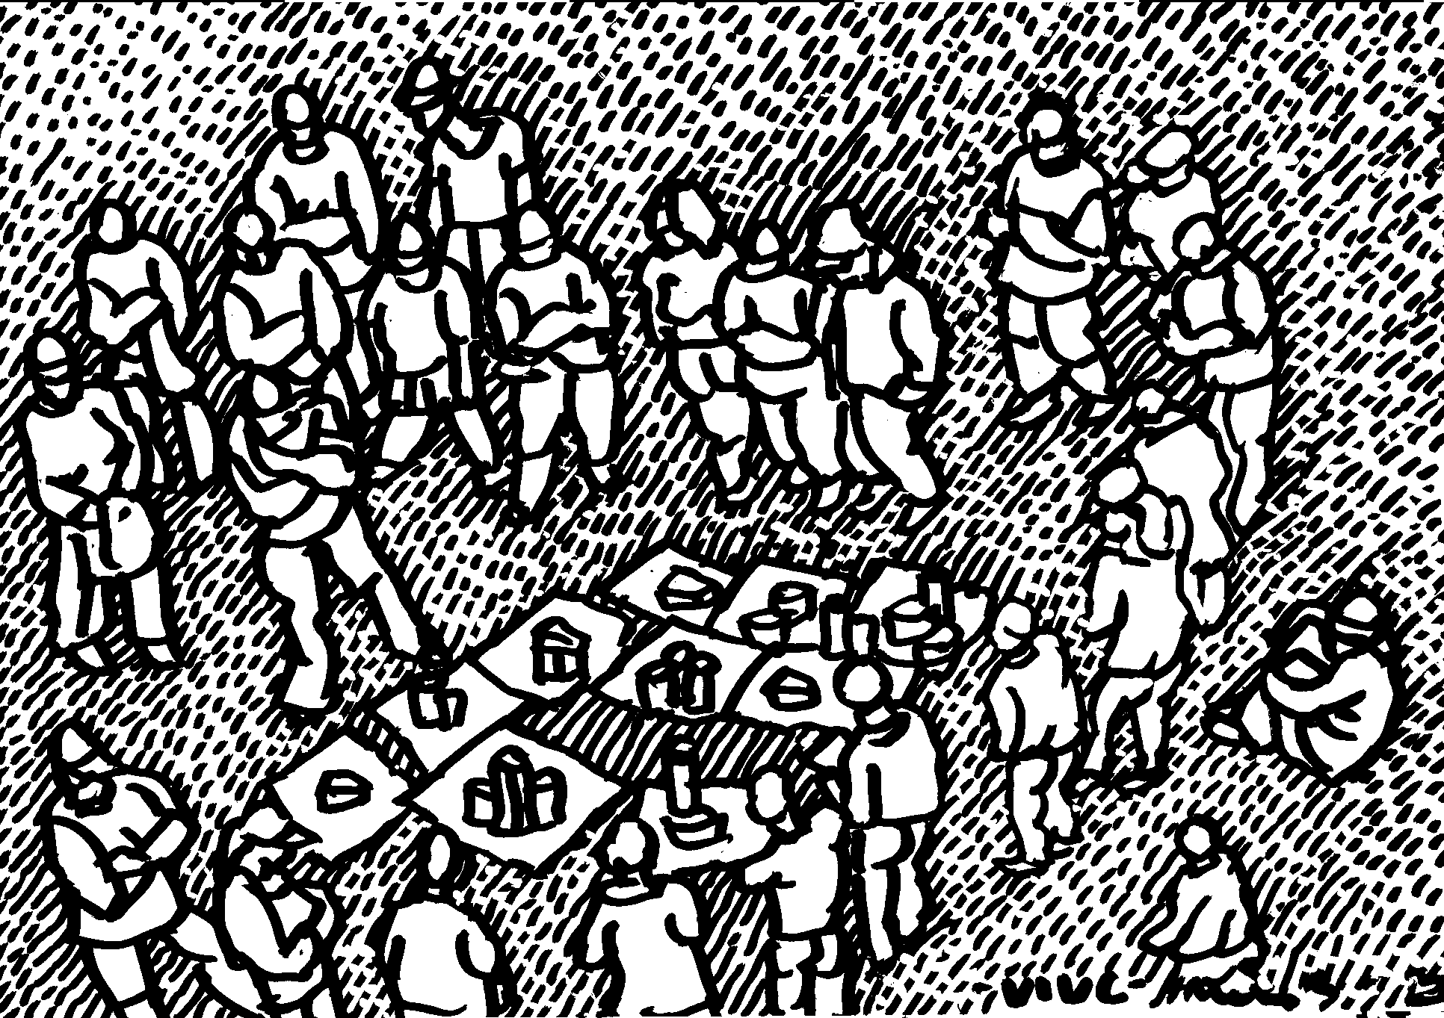

Course Syllabi for fourth-year students in Architecture

Budapest

2oo4

Course Syllabi

- Introduction
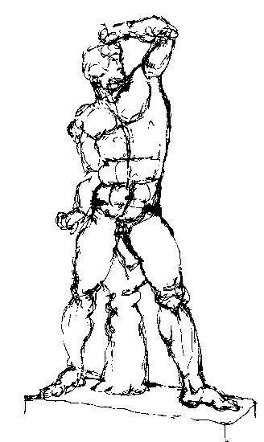
- Head Drawing I. (Structure of the Head – a plaster)

- Head Drawing II. (Living model)

- Figure drawing I. (Structure of the Figure – a plaster)

- Figure drawing II. (Living model)

- Dresses (Drapery studies, costumes)

- Movements I. (Standing figures)

- Movements-rajz II. (Sitting positions)

- Movements-rajz III. (Laying figures)

- Activities (expressed through distinguishing movements)

- States of mind (expressed through typical movements)

- Wet techniques (lavish, colored bases, white lifting)

- Depicting of the Crowd (Outdoor drill of the Multitude)

- Semester’s final task (Fitting our collected and simplified mid-semester figures into the first stage of an imaginary theatrical scene of which the structure shall be earlier determined through orthogonal pictures)

- Eligible home works: a) Human body studies: face and hand expressions, face details or: b) Building scuplture and similar details
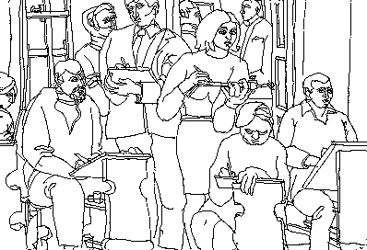

Summary

The perspective view revives if it contains scenes relating to the building’s function. We may choose characteristic figures and tools to each purpose. These scenes (living pictures) are made of objects and figures waiting for being fit into their designed environment.
After having roughly learned through indoor plaster studies the main proportions of the human face and body, we shall practise the technique of “quick-drawing” via croquies. We may assemble moving people ( arriving e. g on escalator) with the help of their repeting details observed on different subjects. Thus the basic figure of the crowd may be put together of parts of diverse people getting constantly into the same position.
Our technical goal is to present linearily different scenes.

Formule:

Figure + Movement + Tools + Site = a typical Scene

General Menu

A walking tour arond the Subject

- Historical samples
- Theory

On-the-spot drills

Technical demonstration

Individual work by copying nature

Collection work, detail elaboration

III. Consultation, experimentation, evaluation

