Basic Concepts of Linear Perspective*

Introduction

Practical Hints

Key-words in ABC:

- Basic Phenomena of Linear Perspective (Convergence, foreshortening, covering)
- Breaking into thirds
- Comparison of Inward Fields (framework structures)
- Composition (Subject + surrounding = the Entire Paper)
- Correct position of drawing board (angle, direction)
- Cut-in-Lines of the Background (Contour-intersections)
- The Diagonal Method (corner reflected through opposite halving point)
- Extreme Oblique Lines
- Determination of the Horizon (eye-level)
- Framing Shape (a rectangle of major sizes)
- Halving (Center Point)
- Horizontal Projection (using the upper edge of drawing board)
- Lay-out (Composition in plane, lettering)
- Looking for Key Intersections (e.g. crossing of Vertical Scale with fundamental Square’s rear edge)
- The Master Picture Plane
- Orthogonal pictures (parallel visual rays)
- The Pencil Method
- Perspective (Central projection, Center, Visual ray, Picture plane)
- Picture Plane Mosaic
- Principal Directions
- Proportion (comparison)
- The Proportion Measuring Method (considering the oblique line as a hypotenuse)
- Simple Geometrical Shapes (Regular triangle and Quadrangles with a pair of parallel sides)
- Multilateral Distortion of Perpendicular Sides (Formula “x/Y, X/y”)
- Picture Plane’s Dissection (Easily Measurable Geometrical Shapes)
- Vanishing Point
- Diagonals’ Vanishing Point
- Vertical Projection of Inward Corners (Horizontal planes)
Vertical scale
ASSIGNMENTS

- A regular heap of equal boxes (e.g. matchboxes, cassettes)
- Modeled configurations made of Domino-style stones
- (Themes like “Entrance,” “Play-ground”, “Arcade” or “Labyrinth”)
- with addition of orthogonal pictures.
- Play-cards on horizontal plane (freely or irregularly positioned in 2D)
- A symmetrical system built of play-cards in 3 D
- (e.g. “Tower”, “Palace”, “Gateway”, etc.)
- An irregular heap of different boxes
- Closed and opened boxes (standing, laying and oblique positions)
- A systematic heap of books
- Still life with rectangular bodies

CORRESPONDING ITEMS

- Furniture (Stool, chair, desk, sculptor’s scaffolding, sole of sculpture, etc.)
- Interiors (considered as an increased cube seen from inside)
- Regular spaces (Corridor, entrance hall, a room’s corner, arcade, etc.)
- Details of built environment (Column, balk, rafter, sill, staircase, etc.)

Aspects for self-evaluation
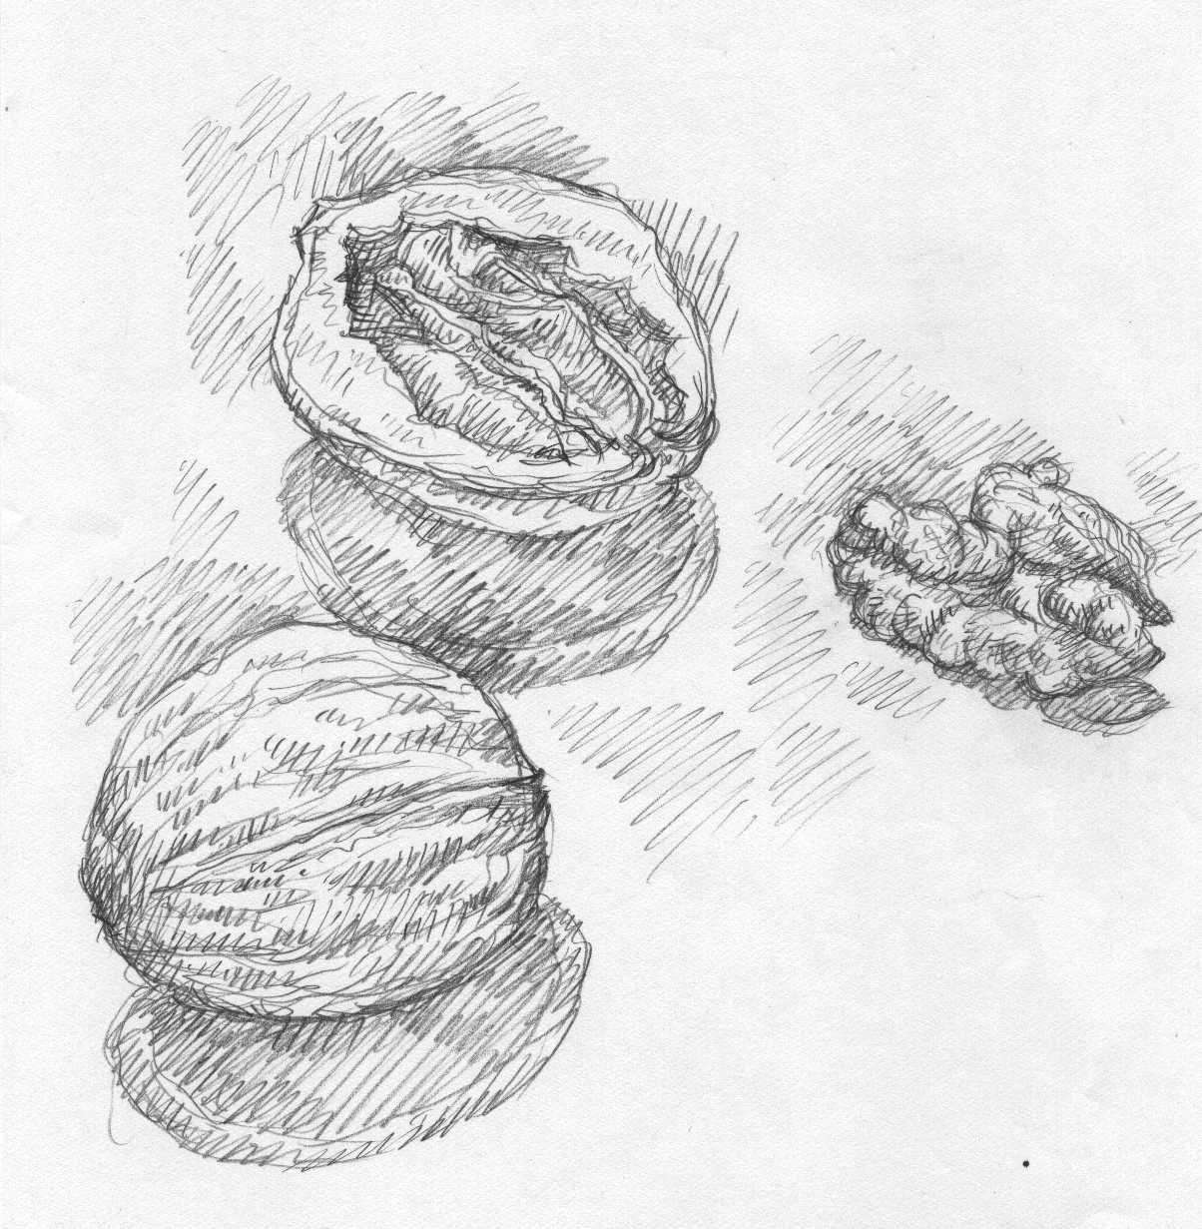

PERSPECTIVE

COMPOSITION

TECHNIQUE

Look for the best “cut-out” of picture by preliminary sketching!
Depict objects with their environment!
The main subject and its surrounding together create the composition.

