Dr Balazs MEHES:

Reflected Tower Trio

Basic Cases of Perspective

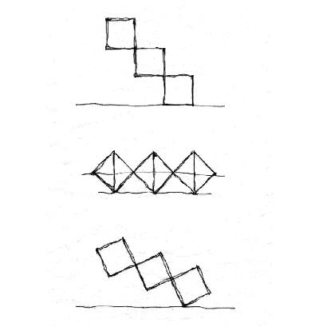

Budapest

2oo5
Reflected Tower Trio
Basic Cases of Perspective

Key-words: Convergence, Extreme Oblique Line, Foreshortening, Framing Shape, Front Plane, Grid Point, Horizon, Lateral Sides’ Ratio, Negative Triangle, Object’s Picture Plane, Oblique Line of In-between, Orthogonal Picture, Principal Direction, Principal Visual Ray, Proportion, Sight from Above, Sight from Below, Structural Grid of Basic Lines, Vanishing Point, View-Point, Visual Cone.

Creating the structure of perspective, in Architectural Freehand Drawing we simplify volumes and spaces by enveloping them into framing shapes. The formation of framing shapes consists of a transparent grid composed of framework cubes. Within the perspective picture, reality’s parallels seem to converge into a distant Vanishing Point. While gradually approaching to this rectangular system we soon recognize that some vanishing points seem to glide out our visual cone!
To their possible position extreme oblique lines relate.

Birth of Perspective

I – Phenomena: Convergence, Foreshortening

We reduce our environment to vertical and horizontal planes outfitted with a square net. Let us first examine the floor’s network – through a quadric grid held vertically! What do we see?
Longitudinal joints are converging. The only subdivision which seems to remain vertical intersects our Vanishing Point on the Horizon. Horizontal subdivisions remain parallel but going backwards interim distances are diminishing. Moving off the Horizon, subdivision distances are increasing. The originally equal row widths of network seem to become narrower backwards. Moving off the central vertical subdivision, the virtual slanting of longitudinal lines grows. Even the diagonals of the square net (being parallel in reality) seem to converge. These diagonals will run toward their own Vanishing Point. With the help of the first diagonal, we may comfortably construct near grid points on the floor plane as shown on Fig. 2.
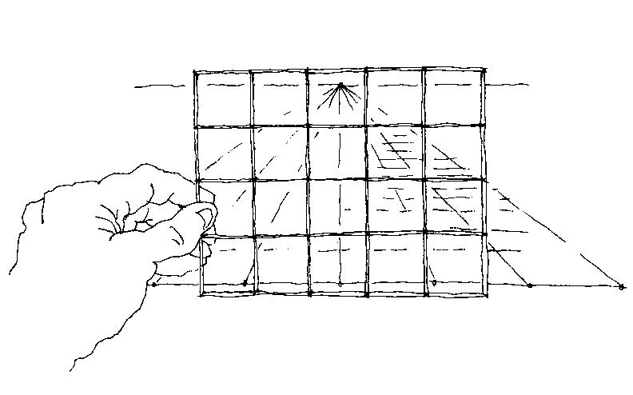
Fig. 1. Gazing at floor’s network through a grid:
Central projection (that means: perspective) will only be true if the picture plane and observer’s principal visual ray are perpendicular to each other. While examining of perspective distortions of the floor’s quadratic network, let’s held the grid vertically!

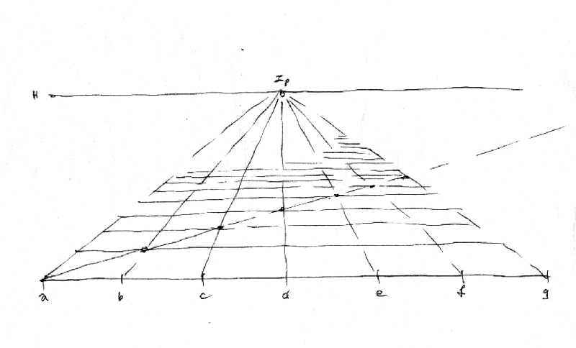

Fig. 2. Components of floor’s network – The case of Single Vanishing Point Perspective

Lateral subdivisions (equal by rows) becoming narrower backwards, longitudinal lines converge. Horizon and Vanishing Point. Diagonal construction of near grid points.

I / a – FINDING OF HORIZON

It would be difficult to guess the horizon’s height without a solid vertical scale. Following the original floor subdivisions, let’s vertically raise imaginary walls equipped with squares! Now, at positive and negative corners, we may observe the changing of the surface grid. Where reality’s horizontal lines fall in a single line (that means that the zigzagging stops) will the Horizon belonging to our position be.

Fig.3. Where the “zigzagging” straightens will our horizon be.
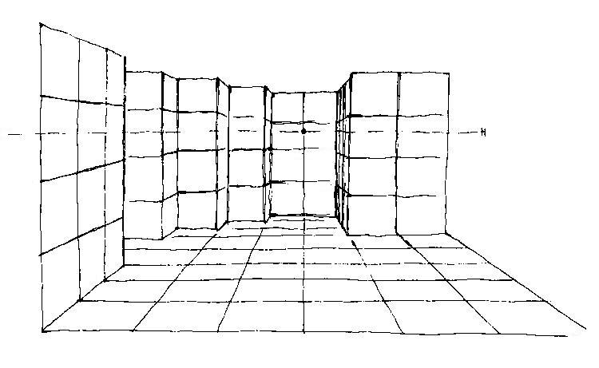

We’ll find the exact position of horizon belonging to our view-point by carefully observing the wall’s surface subdivision at positive and negative corners (brick or stone layers).

II – Causes: Perspective as Central Projection

In the history of perspective rendering the original problem was how to depict an opening door. (Early solutions are shown e.g. on Greek vases.) Artists of the Renaissance - Alberti, Brunneleschi, Dürer and others – looking through the web of a weaving loom, discovered the geometry in perspective. We should get acquainted with basic rules by studying of framework cubes.

DIAGONALLY POSITIONED TOWER TRIO WITH ITS MIRROR PICTURE

Let’s examine regular prisms positioned in a diagonal row! Let’s place the model on a reflecting water surface and walk around!! Our tower trio seems to be appropriate for studying basic phenomena of perspective distortions.
Considering the relation between the observer’s position and the subject’s front plane, we may distinguish three basic cases. They are the parallel (frontal), the symmetrical (diagonal) and the general cases.
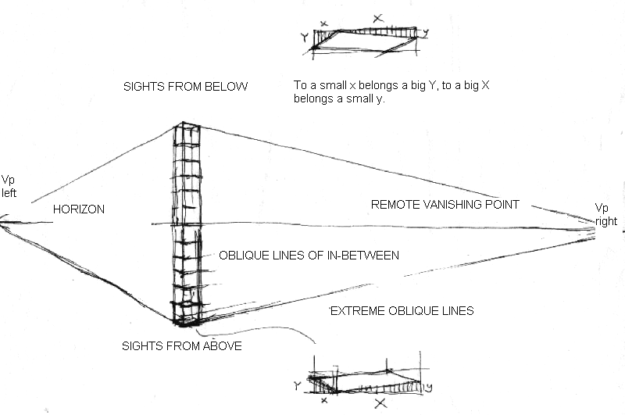

Fig. 4. Basic data – A solo tower with its reflection seen from afar (Parts of the figure: Vanishing Points, increased extreme planes, view from above, view from below, extreme oblique lines and oblique lines of in-between)

Both vanishing points happen to stay on the same paper only if the object is rather tiny (that means it is seen from a big distance) or the paper is extremely large.
RELATION BETWEEN OBJECT’S FRONT PLANE AND OBSERVER’S PICTURE PLANE

The number of vanishing points belonging to the structural grid is up to us! Standing frontally, we’ll have a solo vanishing point. Walking around the tower, we’ll have to do with two vanishing points. Approaching to the tower, even verticals start slanting – a third vanishing point will appear.
We’ll better understand the changing of horizontal distances between verticals (called as lateral sides’ ratio) if we know the connection between the picture plane and the relevant frontal plane. While creating perspective, we ought to keep in mind the site plan (top view) as well.
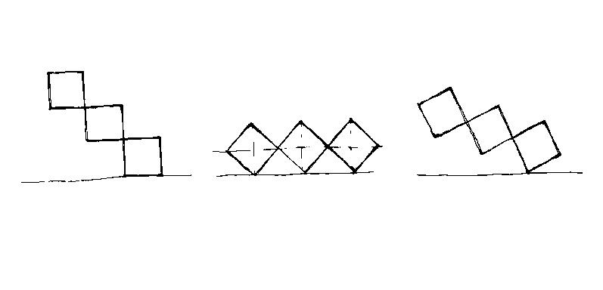

Fig. 5. Three basic cases on relation between front and picture plane (F / P)

(A) Frontal view (F is parallel to P) – single vanishing point perspective
(B) Diagonal view (P is perpendicular to the diagonal) – symmetric case, two Vp
(C) General view (F is not parallel to P) – two vanishing points
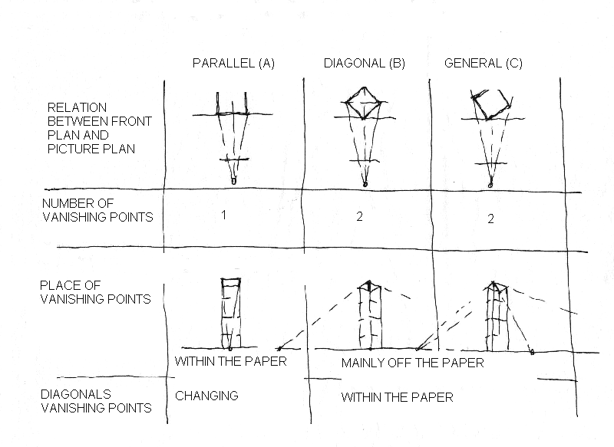

Fig. 6. Chart on relation between front plane and picture plane
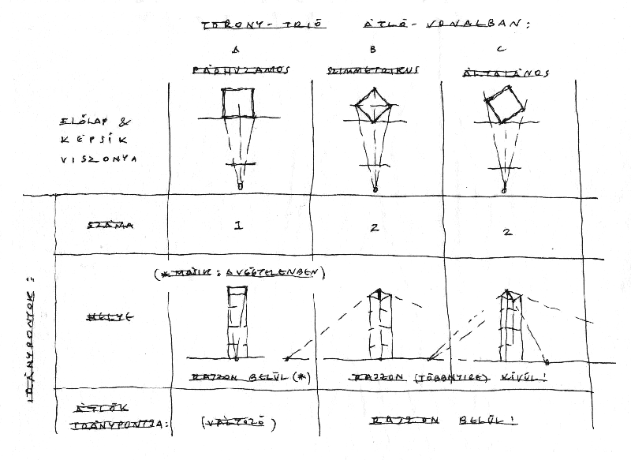
PARALLEL CASE (A)
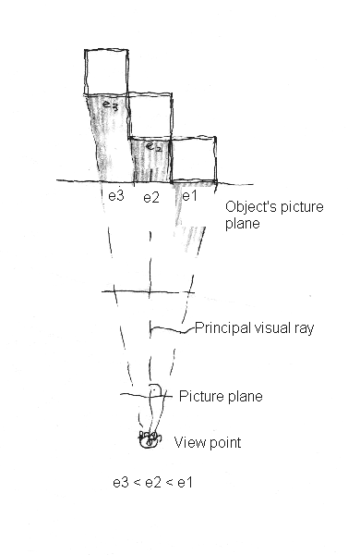
Fig. 7. Parallel case, in plan

This figure is particularly suitable for explaining some of central projection’s key-words (projection, picture plane, central view-point, visual ray and picture’s distance). Let’s carefully observe frontal planes getting narrower! (e₃ < e₂ < e₁)

The sequence of drawing might be like this: near verticals first, vertical subdivisions (havening) extreme oblique lines, oblique lines of in-between, backside planes then the same in mirror picture, next a control of convergence (through diagonal’s vanishing point), etc. Let’s examine sections’ coincidence as if the tower were transparent! Lately we ought to control extreme planes of nearby towers as well where distortions are the largest! The quality of backside squares also counts!
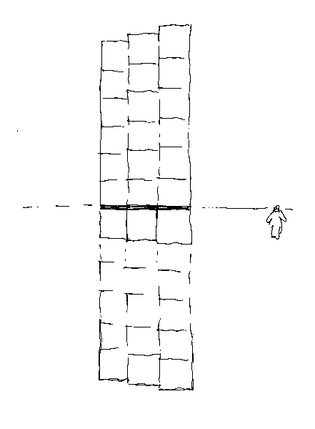
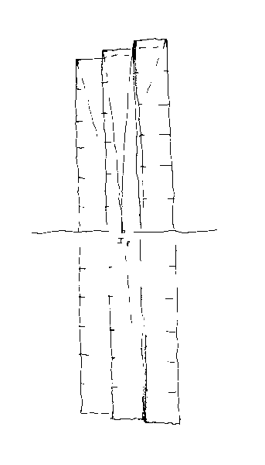
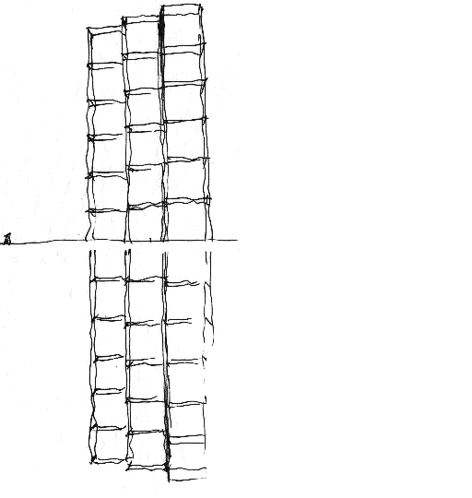

Fig. 8. Parallel case,  in perspective | Fig. 9. Parallel case  Solo Vp is within the paper | Fig. 1o. Changing of Horizon (Changing of Scale)
Next let’s change the place of Horizon! When lifting our Horizon off the floor’s level, a soft transition between object- and volume- (or space-) drawing will be realized. At object drawing views from above are more often, at space drawings views from below can’t be avoided. One side product of our analysis is Fig. 1o: the key for scale changing is hidden within the moving of Horizon.
SYMMETRIC CASE (B)

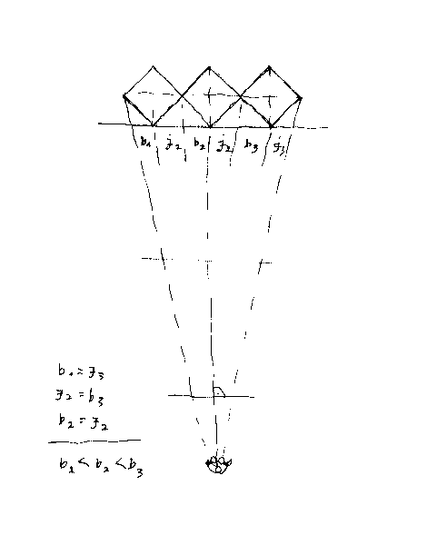

Fig. 11. Symmetric case in plan

Seeing one diagonal of the basic square as horizontal, the other will be vertical. The virtual heights of extreme corners seem to be equal. Opposite side-sections are equal, but those of the same side are gradually changing (b₁ < b₂ < b₃)

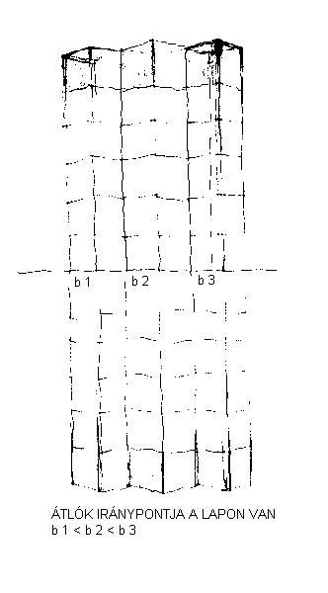
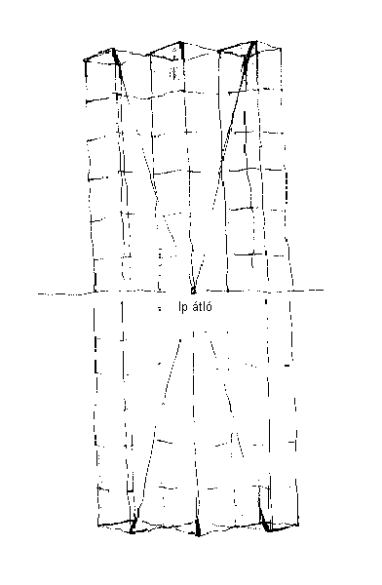
Fig. 12. Symmetric case in perspective  (b₁ < b₂ < b₃ ) | Fig. 13. Symmetric case in perspective  Diagonals’ Vanishing Point will remain on paper.

GENERAL CASE (C)
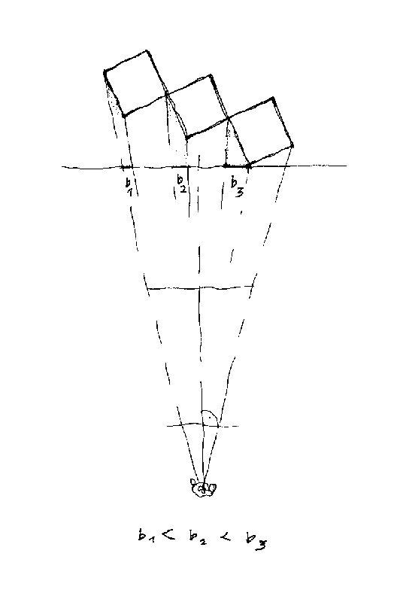
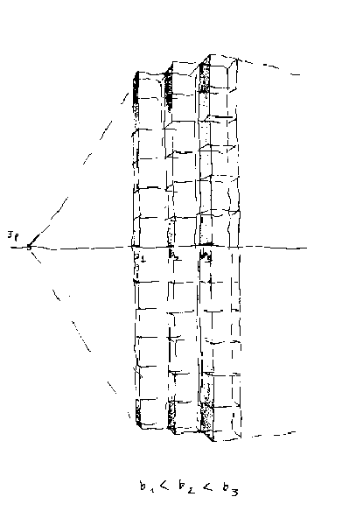

Fig. 14. General case in plan(C)  Let’s observe lateral sides’ row getting narrower! (b₁ < b₂ < b₃)  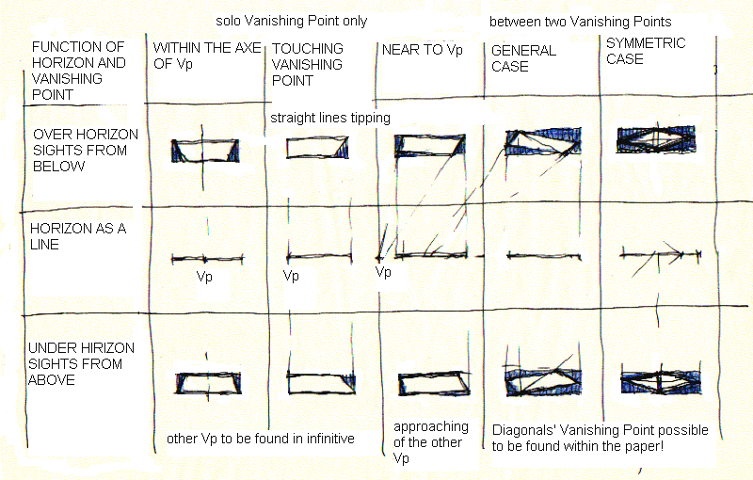 | Fig. 15. General case in perspective – changing of smaller side-sections. Approaching to vanishing point, sections soon disappear b₁ < b₂ < b₃).

Fig. 16. Overview of distortions belonging to structural grid’s horizontal planes
Chart’s central row shows the movement of Vanishing Point on the Horizon as seen by the Observer walking around the tower. In the course of walking around, the moving Vanishing Point of squares’ edges is slowly getting off our visual cone. Meanwhile (as a comfort) the Vanishing Point of Diagonals gradually enters. Due to the fact that squares’ diagonals in reality are parallel, they’ll also own a Vanishing Point in perspective.
III – DISTORTION OF EXTREME PLANES - DETAILS

Approaching to the view, we nay finalize details through thorough fully analysis of details. Distortions belonging to extreme planes ought to be determined with the help of framing shape’s negative triangles. The framing shape is a rectangle having right angles parallel to paper’s corners. After having examined all negative triangles of the framing shape, the slanting of extreme oblique lines might be translated into treatable numbers.
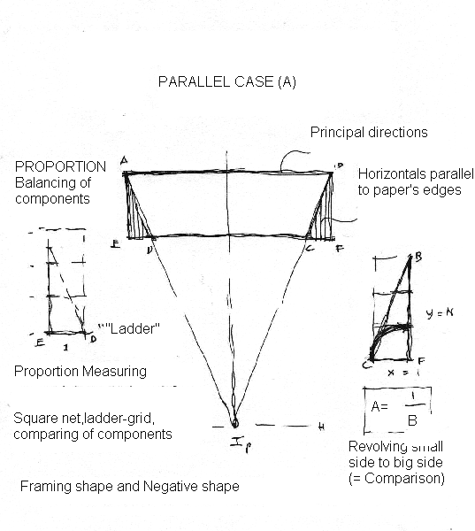
Fig. 17. Parallel case (A)

Here we may explane following key-words: principal direction, negative shape, framing shape, main dimension, component measuring. „Aránymérés” során a kisebb befogót ráforgatjuk a nagyobbra (ekkor keletkezik a „létra”-In the course of Proportion Measureing we cover the big side with the small side (thus a “ladder” motive appears). Calculating proportion we re-measure the rest back to the whole in order to achieve a usable fraction.

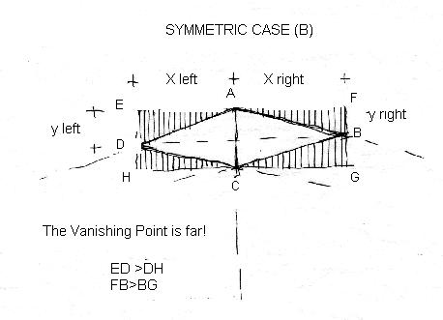

Fig. 18. Symmetric case (B)

Mutual impact of diagonals – If the one diagonal is vertical, the other will virtually be horizontal.
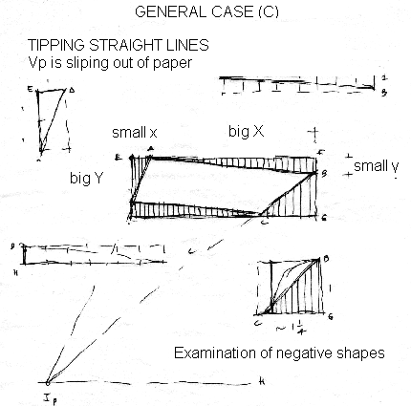
Fig. 19. General case (C)

Parts of the framing rectangle: two pairs of negative triangles with certain connection. Between foreshortening sides an inverse ratio exists
To larger side belongs a smaller virtual height. („To small y belongs a big X , to big Y belongs a small x”.) Last we also control the convergence of extreme oblique lines. We compare the virtual height of corners through horizontal projection.
Summary

We reduce the world of objects into a structural grid of transparent cubes. Through analyzing the relation between a tower’s front plane and the observer’s picture plane, we distinguish three basic cases of perspective. They are: the frontal (parallel), the diagonal (symmetrical) and the oblique (general) case.
In perspective, the real world’s parallel lines seem to converge into a distant Vanishing Point. If these parallels lay on horizontal planes, their Vanishing Point will also stay on the Horizon. The number of vanishing points is up to our standing position. Some vanishing points happen to be afar of drawing paper’s edge. Yet within our simplified cubic structure, extreme oblique lines clearly point toward hidden vanishing points.
In lack of direct Vanishing Points, but knowing the horizon’s position, we may employ the Diagonals’ Vanishing Point for controlling essential framework points.
Preliminarily chosen object’s dimensions and one Vanishing Point do consequently determine the other Vanishing Point’s position.
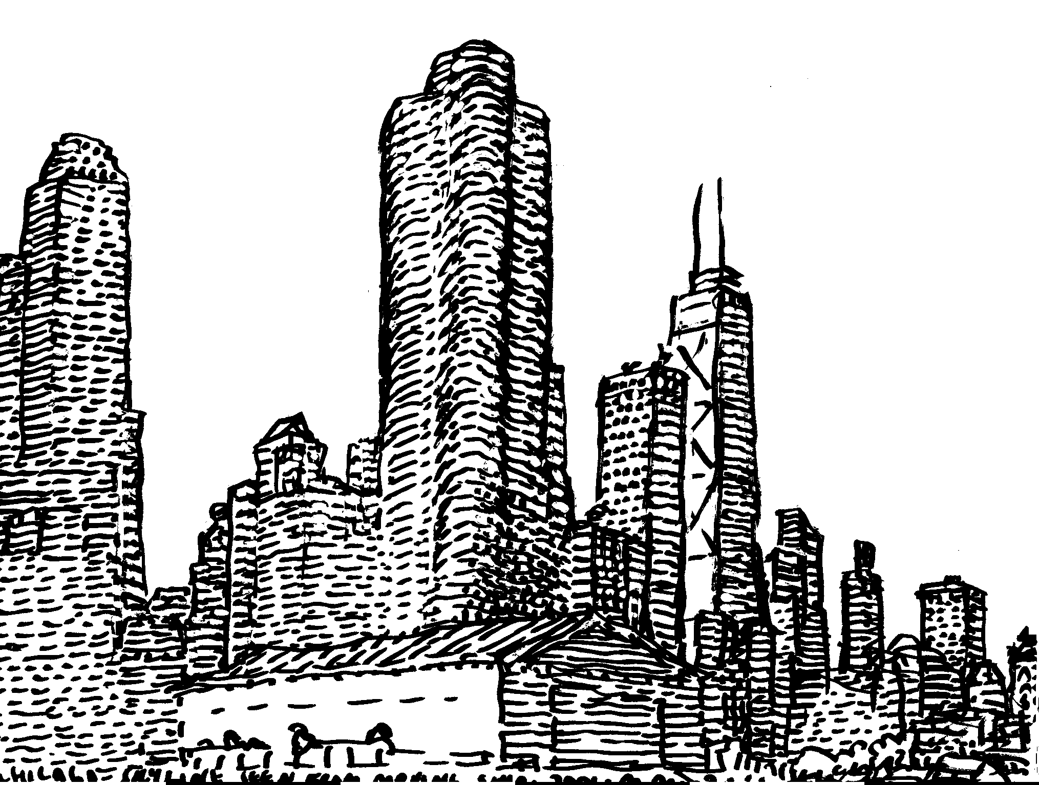

Balazs Mehes: Chicago skyline as seen from a moving ship, 2oo1 (felt pen)

